 | 7.1.10 Editors - 3D Viewport - Header - Mesh - Edit Mode - Vertex Menu
Table of content
Detailed table of content 1
Edit Mode - Vertex Menu 4
Legacy 4
Extrude to Cursor or Add 9
Make Edge/Face 9
Connect Vertex Path 10
Connect Vertex Pair 10
Smooth Laplacian 10
Vertex Crease 11
Merge Vertices 12
By Distance 12
Vertex Groups 13
Hooks 14
Make Vertex Parent 15

Detailed table of content
Detailed table of content
Detailed table of content 1
Edit Mode - Vertex Menu 4
Legacy 4
Bevel 4
Last Operator Bevel 4
Affect 4
Width type 4
Segments 4
Shape 4
Material Index 5
Harden Normals 5
Clamp Overlap 5
Loop Slide 5
Mark Seams 5
Mark Sharp 5
Outer Miter 5
Sharp 5
Patch 5
Arc 5
Inner Miter 5
Sharp 5
Arc 5
Spread 6
Intersections 6
Face Strength Mode 6
None 6
New 6
Affected 6
All 6
Rip Vertices 6
Last Operator Rip 6
Move X , Y , Z 6
Constraint Axis 7
Orientation 7
Proportional editing 7
Proportional Falloff 7
Proportional Size 7
Connected 7
Projected(2D) 7
Rip Vertices and Fill 7
Rip Vertices and Extend 7
Last Operator Extend Vertices 7
Move X , Y , Z 7
Constraint Axis 7
Orientation 7
Proportional editing 8
Proportional Falloff 8
Proportional Size 8
Connected 8
Projected(2D) 8
Vertex Slide 8
Last Operator Vertex Slide 8
Factor 8
Even 8
Flipped 8
Clamp 8
Correct UV's 8
Smooth 9
Last Operator Smooth Vertices 9
Smoothing 9
Repeat 9
X Axis, Y Axis, Z Axis 9
Extrude to Cursor or Add 9
Last Operator Extrude to Cursor or Add 9
Location X Y Z 9
Make Edge/Face 9
Connect Vertex Path 10
Connect Vertex Pair 10
Smooth Laplacian 10
Last Operator Laplacian Smooth Vertex 10
Number of Iterations 10
Lambda Factor 10
Lambda Factor in border 10
Smooth Axis 10
Preserve Volume 10
Vertex Crease 11
Last Operator Vertex Crease 11
Factor 11
Blend from Shape 11
Last Operator Blend from Shape 11
Drop-down box 11
Blend edit box 11
Add 11
Propagate to Shapes 11
Merge Vertices 12
At First 12
At Last 12
At Center 12
At Cursor 12
Collapse 12
Last Operator Merge 12
Type 12
UV's 12
By Distance 12
Last Operator Merge by Distance 12
Merge Distance 12
Unselected 12
Vertex Groups 13
Assign to New Group 13
Assign to active Group 13
Remove from Active Group 13
Remove from All 13
Set Active Group 13
Remove Active Group 13
Remove All Groups 14
Hooks 14
Hook to New Object 14
Hook to Selected Object 14
Last Operator Hook to Selected Object 14
Active Bone 14
Hook to Selected Object Bone 14
Assign to Hook 14
Remove Hook 15
Select Hook 15
Reset Hook 15
Recenter Hook 15
Make Vertex Parent 15
Workflow: 15

Edit Mode - Vertex Menu

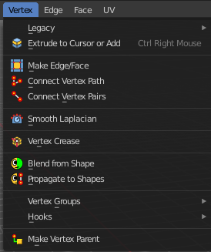
The Vertex menu just exists for mesh objects. It provides you with tools that are designed to modify vertices.

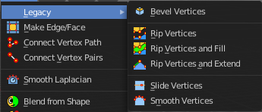
Legacy
The legacy sub menu contains tools that exists in the tool shelf already. It's the old way to do things. Different to the tools in the tool shelf, these tools are usually modal. And performs once. You have to call them again in case you want to repeat the tool.

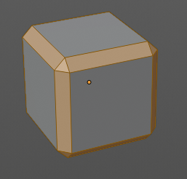
Bevel
The Bevel Tool adds a bevel to the selected geometry.
Usage: first select the geometry that you want to bevel. Then activate the tool. Don't wonder that the mouse movement does nothing until you move the mouse really really far away. That's by design. Best is to adjust the amount in the Last Operator Bevel panel.

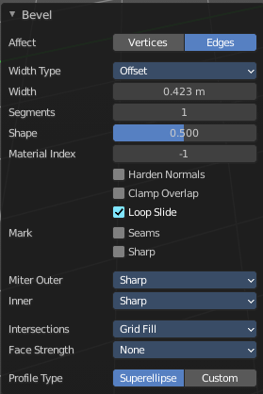
Last Operator Bevel

Affect
What geometry to bevel. Vertices or Edges.

Width type
Which measure type to choose for the bevel action. Offset, Width, Depth or Percent.

Segments
How many segments gets created.

Shape
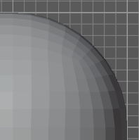
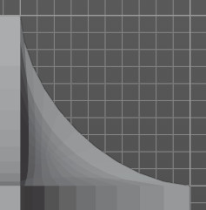
Controls the profile shape strength. A value close to 0 bends the roundness to inside. A value towards 1 bends the curve to outside. A value of 0.5 defines a radius around the center point of the bevel.

Material Index
The material for bevel faces. -1 means to use the material from the adjacent faces.

Harden Normals
Match normals of new faces to adjacent faces.

Clamp Overlap
Do not allow beveled geometry to overlap each other.

Loop Slide
Prefer slide along edge to even widths.

Mark Seams
Mark the edges of the new created geometry as seams.

Mark Sharp
Mark the edges of the new created geometry sharp.

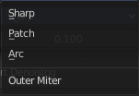
Outer Miter
How the outer miter is set. Miter is how the bevel rounding at a corner is done.


Sharp
Creates a sharp miter.

Patch

This replaces the outside vertex of a miter with 3 vertices. And uses a patch pattern there.

Arc

This replaces the vertex of a miter with 2 vertices, joined by an arc. A separate Spread parameter says how far to move the vertices away from their original position.

Inner Miter
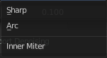
How the inner miter is set. Miter is how the bevel rounding at a corner is done.

Sharp
Creates a sharp miter.

Arc
This replaces the vertex of a miter with 2 vertices, joined by an arc. A separate Spread parameter says how far to move the vertices away from their original position.

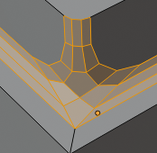
Spread
Belongs to inner miter method Arc. Adjust how strong the inner radius is bent.

Intersections
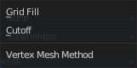
The method to use to create meshes at intersections. Bevel can create self intersecting geometry.

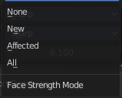
Face Strength Mode
Set Face Strength on the faces involved in the bevel, according to the specified mode. This can be used in conjunction with a Weight Normals Modifier (with the Face Influence option checked).

None
Do not set face strength.

New
Set the face strength of new faces along edges to Medium, and the face strength of new faces at vertices to Weak.

Affected
In addition to those set for the New case, also set the faces adjacent to new faces to have strength Strong.

All
In addition to those set for the Affected option, also set all the rest of the faces of the model to have strength Strong.

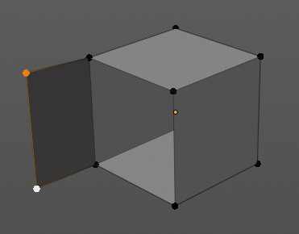
Rip Vertices
Rip splits the edges between the selected vertices. It creates two edges out of one.
This tool works similar to the Edge Split tool. It also selects the outer edges so that you immediately move them. Right click will snap them back to the initial space.

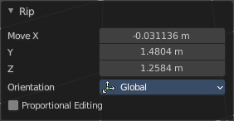
Last Operator Rip

Move X , Y , Z
Adjust the position.


Constraint Axis
Limit the position relative to the source object.

Orientation
Orientation is a drop-down box. Choose the type of orientation for the mirroring action.

Proportional editing
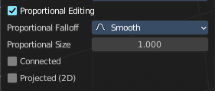
Enables proportional editing. Activating proportional editing reveals further settings.

Proportional Falloff
Adjust the falloff methods.

Proportional Size
See and adjust the falloff radius.

Connected
The proportional falloff gets calculated for connected parts only.

Projected(2D)
The proportional falloff gets calculated in the screen space. Depth doesn't play a role. When it's in the radius, then it gets calculated.

Rip Vertices and Fill
Rip splits the edges between the selected vertices. It creates two edges out of one. But fills the gap.
The last operator is the same than for the rip vertices tool above.

Rip Vertices and Extend
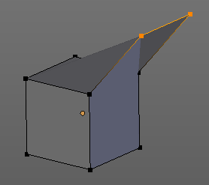
This tool is the same tool than the Rip Edge tool from the tool shelf.
Rip Vertices and Extend extrudes out the selected vertices. When you do this operation at an edge then you will create N-Gons that way.

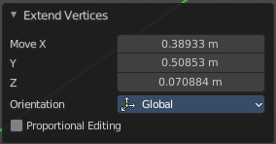
Last Operator Extend Vertices

Move X , Y , Z
Adjust the position.

Constraint Axis
Limit the position relative to the source object.

Orientation
Orientation is a drop-down box. Choose the type of orientation for the mirroring action.

Proportional editing
Enables proportional editing. Activating proportional editing reveals further settings.

Proportional Falloff
Adjust the falloff methods.

Proportional Size
See and adjust the falloff radius.

Connected
The proportional falloff gets calculated for connected parts only.

Projected(2D)
The proportional falloff gets calculated in the screen space. Depth doesn't play a role. When it's in the radius, then it gets calculated.

Vertex Slide
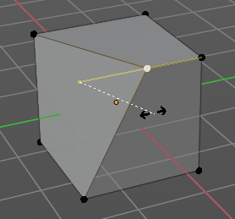
Same tool than the Vertex Slide in the Tool Shelf. Vertex Slide slides the selected vertice along the edge that it is part of. This is for the corner vertice at a cube into three possible directions.

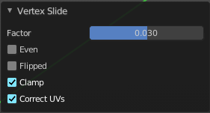
Last Operator Vertex Slide

Factor
Factor is a sliding box Adjust the slide strength numerically. The width of the face is the 0-1 range.

Even
Make the Edge loop match the shape of the adjacent edge loop.

Flipped
When Even Mode is active, flips between the two adjacent edge loops.

Clamp
Clamp within the edge extend.

Correct UV's
Correct UV's corrects the UV's while editing the geometry.

Smooth
Same tool than in the tool shelf. Smoothens the selected vertices.

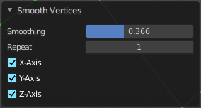
Last Operator Smooth Vertices

Smoothing
The smoothing factor.

Repeat
How often the smoothing should be applied.

X Axis, Y Axis, Z Axis
Which axis to affect.

Extrude to Cursor or Add
Hotkey only tool. Extrude to the mouse position.

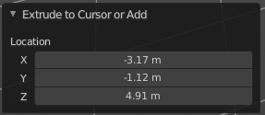
Last Operator Extrude to Cursor or Add

Location X Y Z
The location to extrude to.

Make Edge/Face
Adds a face when you have edges selected. And Edges when you have Vertices selected. It's a Bridge tool.
You can have either the one method or the other. When you select two adjacent vertices, then you select the edge too. And the tool works in edge mode then. In this case just the possible faces gets created. Not edges between single vertices.
First select the edges or Vertices that you want to bridge. Then click the New Edge/Face from Vertices Button.
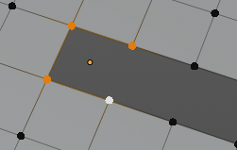
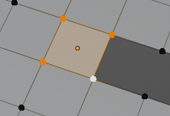
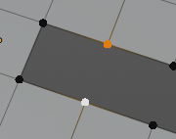
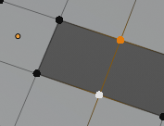

Connect Vertex Path
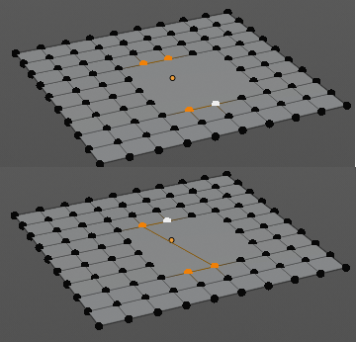
Connect Vertex path connects selected vertices, but takes the vertex order into account in which you selected the vertices. It just creates edges between vertices that are not connected in this order.

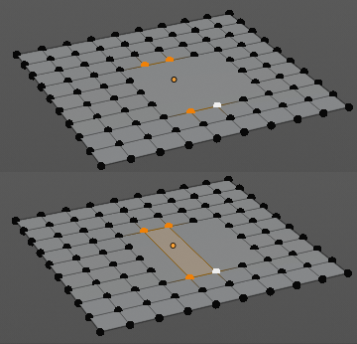
Connect Vertex Pair
Connect Vertex pair connects selected vertices and makes a face of the pairs.

Smooth Laplacian
Laplacian Smooth Vertex smooths out the angles between the selected vertices. It is a tool to reduce noise at the mesh. It works a bit different than the normal Smooth Vertex tool. And gives a different result. The Laplacian method allows you to preserve the volume, and to adjust border smoothing.

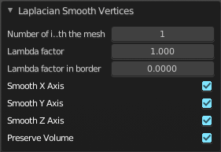
Last Operator Laplacian Smooth Vertex

Number of Iterations
Number of Iterations is the number of iterations that the smoothing action gets repeated. With 1 the smoothing is just performed once. With 10 it is performed ten times.

Lambda Factor
Lambda Factor is the strength of the smoothing.

Lambda Factor in border
Lambda Factor is the strength of the smoothing in border areas.

Smooth Axis
The Smooth Axis check boxes allows you to limit the smoothing to specific world axis.

Preserve Volume
Preserve Volume preserves the volume of the object.

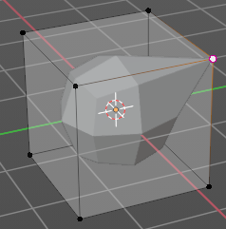
Vertex Crease
When you use a Subdivision Surface Modifier, then you can define the sharpness of selected vertices with this tool. Crease vertices will be marked colored in edit mode.
You will see a value in the header that indicates the current strength when you activate the tool. Move with the mouse to increase or decrease the value. Or type in a value while you are in this mode. You can also scale into negative range.

A negative crease value will subtract from the current active crease value in case it exists already from a former crease operation. A Crease value of -1 removes the crease from this edge.

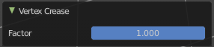
Last Operator Vertex Crease

Factor
Adjust the crease factor.

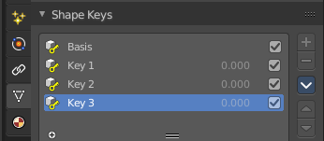
Blend from Shape
This tool requires to have a shape key at the mesh. It blends the selected shape key into the mesh.

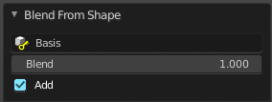
Last Operator Blend from Shape

Drop-down box
Define which shape key should be used.

Blend edit box
Adjust the blend factor between the current shape and the shape that you want to blend here.

Add
Add to blend shape instead of blending in.

Propagate to Shapes
This tool requires to have a shape key at the mesh. It applies the current vertex locations for the selected vertices to all other shape keys at the mesh.

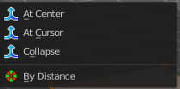
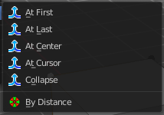
Merge Vertices
Merge vertices together. When you pick a vertice, and add more vertices to the selection, then you get two more tools, to merge to the first or last vertice. When you box select, or use select all, then you get just the other three tools.

At First
Merges the current selected vertices at the first selected vertice.

At Last
Merges the current selected vertices at the last selected vertice.

At Center
Merges the geometry at the center of the selected vertices.

At Cursor
Merges the geometry at the 3D Cursor.

Collapse
Merges the geometry at the center of the selected vertices.

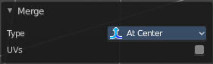
Last Operator Merge

Type
Type is the drop-down box again where you can choose what method to use for merge.

UV's
With UV's ticked the UV mapping will update with changes at the geometry.

By Distance
Merges vertices that are very close to each other. The merge happens at the center. When you need more control then you should use the Merge Vertices tool.

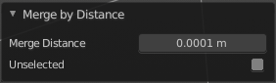
Last Operator Merge by Distance

Merge Distance
Adjust the distance in which the vertices gets merged.

Unselected
Merge selected vertices also with other unselected vertices.

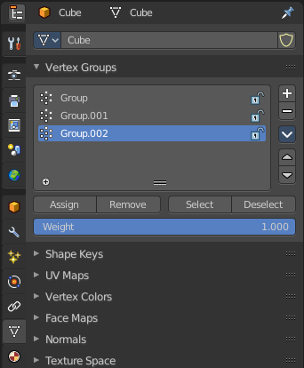
Vertex Groups
Vertex groups is a menu around vertex group functionality. The vertex groups can be found in the Object data tab in the Properties editor.
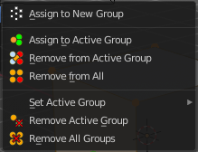

When there is no vertex group assigned yet then you can only see one menu item. The Assign To New Group button.
Once you have a vertex group assigned you will see the full functionality.

Assign to New Group
Assigns the mesh selection to a new vertex group.

Assign to active Group
Assigns the mesh selection to the currently active vertex group.

Remove from Active Group
Removes the mesh selection from the currently active vertex group.

Remove from All
Removes the mesh selection from all vertex groups.

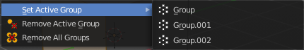
Set Active Group
Select a vertex group to be the active one.

Remove Active Group
Removes the currently active vertex group.

Remove All Groups
Removes all vertex groups from the mesh.

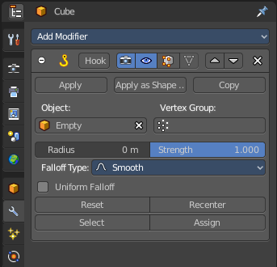
Hooks
Hooks is a menu with tools around the hook modifier. You could also adjust the hook modifier from the Properties editor. But the menu items are more accessible.
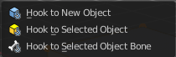
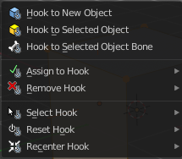

When there is no hook modifier at the mesh then you just see three menu items. When there is minimum one hook modifier applied, then you will see an extended menu.

Hook to New Object
Creates a new Hook Modifier for the active object and assigns it to the selected vertices. It also creates an empty at the center of those vertices, which are hooked to it.

Hook to Selected Object
Does the same as Hook to New Object, but instead of hooking the vertices to a new empty, it hooks them to the selected object (if it exists). There should be only one selected object (besides the mesh being edited).


Last Operator Hook to Selected Object

Active Bone
Hook to the object(s) of the active bone.

Hook to Selected Object Bone
Does the same as Hook to New Object. But it sets the last selected bone in the also selected armature as a target.

Assign to Hook
Assign the selected vertices to the chosen hook modifier. Existing hooks gets overwritten. One vertex can be assigned to more than one hook.

Remove Hook
Removes the chosen Hook Modifier from the object.

Select Hook
Selects all vertices assigned to the chosen Hook Modifier.

Reset Hook
Resets the chosen Hook Modifier.

Recenter Hook
Recenter the Hook Modifier.

Make Vertex Parent
Parents another object to the selected vertice(s).

Workflow:
In Object mode select the object that you want to parent to a vertex. Shift select the parent object so that both are selected. Enter Edit mode. Then select one vertex for a single point. Or three for an area. Then click the Make Vertex Parent button to make the relation.

